Student’s name
Professor’s name
Course title

Chapter 7
- How do the structure and function of the prokaryotic cell flagella differ from those of eukaryotic cells?
Structurally, prokaryotic flagella are simple and small microtubules, made up of the flagellin protein while eukaryotic cells are large and complex microtubules composed of tubulin.
Functionally prokaryotic flagella move by whirling while eukaryotic flagella move in a wipe like motion.

2. Define:
The nucleolus is the largest structure in the nucleus of a eukaryotic cell composed of proteins near specific chromosomal regions and the main function is ribosomal biogenesis.
Endomembrane system is the combination of different membranes suspended in the cytoplasm dividing the cell into functional compartments. Golgi bodies, rough and smooth endoplasmic reticulum and nuclear membrane comprises of some of this organelles.
Lysozymes are spherical vesicles in most animal cells and contain hydrolytic enzymes that break down molecules in a cell.
Autophagy is a regulated mechanism that allows degradation and recycling of unnecessary components in a cell.
Apoptosis is a mechanism of programmed death of cells in multicellular organisms due to changes in the biochemical events of the cell.
Phagocytosis is the engulfment of solid particles to form a compartment termed as a phagosome, either for the purpose of nutrient acquisition or for the purpose of elimination of pathogens.
Contractile vacuoles are organelles whose major role is osmoregulation in a cell.
Plastids are double membrane organelles in plant cells that contain pigments and act as sites of manufacture and storage of chemical compounds used by the cell.

- What is the role of central vacuole in plant cells
The central vacuole holds cellular wastes products that help maintain pressure and the structure of the cell.

- Mitochondria show maternal inheritance. What does this mean? Be ready to sketch and properly label the general structure of mitochondria and the chloroplast.
Mitochondria contain DNA is inherited from the mother because the egg contains a higher number of the mitochondrial DNA compared to the sperm,

- What makes rough endoplasmic reticulum rough? What are some of the functional differences between smooth and rough endoplasmic reticulum? Describe how ribosome's work with the rough ER to produce membrane-bound proteins. How do those ribosomes know to specifically target the ER for the production of these proteins?
The rough endoplasmic reticulum is rough due to the presence of ribosomes on their surface.
Smooth endoplasmic reticulum takes part in the synthesis of lipids used in the production of new cellular membranes while rough endoplasmic reticulum is involved in the process of protein production and folding.
The rough endoplasmic reticulum is located next to the nucleus that contains the messenger ribonucleic acid (mRNA). The N-terminus in the mRNA allows ribosome binding which initiates the translation process copying linear sequences of RNA bases to the basic unit of a protein.
Ribosomes use the signal sequence that binds to the already existing signal recognition particles on the cell cytoplasm.

6) What is the general role of motor proteins in a cell? Can you provide examples of these proteins?
Motor proteins provide a driving force behind active transport in proteins and vesicles in the cytoplasm.
Examples of motor proteins are the muscle protein, myosin

7) The number and size of organelles in a cell correlates with the function of that cell. What might you expect the function to be for a cell that has an extensive amount of rough endoplasmic reticulum? Or, one that has numerous plastids filled with starch?
The function of a cell with an extensive amount of rough endoplasmic reticulum is the synthesis of proteins due to the presence of ribosomes.
A cell with numerous plastids filled with starch acts as a storage tissue.

8) Compare and contrast the structure and internal components of a generalized plant cell, animal cell, and prokaryotic cell. Which features are common to all cells? Which are specific to just prokaryotes, or just plants, or just animals? What is the functional role of the major eukaryotic organelles discussed in class? (Endoplasmic reticulum, Golgi apparatus, lysosomes, mitochondria, chloroplasts, etc.). Table 7.2 in the textbook is a good summary of this information.
Both plants, animal and prokaryotic cells a cell membrane, vesicles, and vacuoles. Plant and animal cells are termed as eukaryotic and have membrane-bound organelles which are not available in prokaryotic cells. Structurally prokaryotic cells are usually smaller than eukaryotic cells. Internally prokaryotic cells have their chromosomal DNA stored in the nucleoid while the eukaryotes have their DNA tightly bound into chromosomes.
Some of the features common to all the cells are the nucleus, ribosomes, cell membrane, cytoplasm, mitochondria, and vacuoles. Plastids are only present in plant cells. Animal cells lack a cell wall that is present in both plant and prokaryotic cells.
The major organelles in cells perform a different function. The endoplasmic reticulum synthesis, fold and transport proteins to the Golgi apparatus.
Golgi apparatus package proteins into bundles in the cell.
Lysosomes contain a hydrolytic enzyme that breakdown unwanted materials in the cell.
Mitochondria act as the site for respiration responsible for energy production in a cell.
Chloroplast contains chlorophyll thus acting the site for photosynthesis.

9) What are some of the antibiotic targets in bacteria that were discussed in class? Why are those specific structures good targets for antibiotic compounds?
Some of the antibiotic targets are the bacterial cell wall and the ribosomes. The bacterial cell wall contains peptidoglycan, unlike human cells that lack a cell wall. The ribosomes have a single site on which the antibiotic attaches thus blocking the process of translation.

10) Cells tend to be small because of a problem involving the ratio of surface area to volume. What is the problem? Why can’t a single cell be the size of a basketball?
The small size allows the cell interact fully with its surrounding environment. If the cell grows larger the volume increases leading to expansion of the cell membrane and thus surface available to pass materials becomes limited.

11) Why do plants need both chloroplasts and mitochondria? What is the evidence that these two organelles were derived as a result of endosymbiosis? Which endosymbiotic relationship arose first? How can we tell?
The chloroplast is the sites for photosynthesis while the mitochondrion is the site for respiration in a plant cell. A symbiotic relationship occurs the two organelles because chloroplast produces glucose as an end product and oxygen as a by-product which is broken down in the mitochondria during the process of respiration to release energy and carbon iv oxide. The carbon IV oxide is utilized by the chloroplast in the process of photosynthesis.
Both mitochondrion and chloroplast began as individual bacterial cells that were further engulfed by larger cells to become organelles.

Chapter 8

12) What are Plasmodesmata? Where are they found? Desmosomes? Gap Junction? Tight Junction?
Plasmodesmata are microscopic channels that evolved independently in plant and some algal cells and enable communication between them. They are found on the cell walls.
Desmosomes are interjunctions present inside a cell and provide strong adhesion between the cells found in the epithelia and cardiac muscles.
A gap junction is a specialized intracellular connection from the cytoplasm of one cell to another in animals and allows the exchange of molecules and ions between the cells.
A tight junction is a fluid impermeable barrier formed because of the close association of two cells.

13) Steroids have the ability to pass through the cell membrane and into the cytosol. How is this possible? What is their subsequent path to achieve an impact on the function of the cell?

Steroids are lipophilic molecules and thus dissolve in the lipid bilayer in the cell membrane allowing them to pass into the cytosol.

14) In general, what is a signal transduction pathway, and how can it amplify the message that’s being sent to a cell?
A signal transduction pathway is a chain of chemical reactions initiated by the attachment of a molecule the receptors on the cell membrane. The pathway creates communication between the inside and the outside of a cell. The second message being sent to a cell is amplified through coupling it downstream to multikinase cascades.

15) In cellular communication, what are the impacts of paracrine, endocrine and synaptic signaling? How does each function?
Paracrine signaling functions by producing signals that induce impacts to the neighboring cells causing change in their behavior
Endocrine signaling is the by the production of chemical messages such as hormones that are released into the body through the bloodstream.
Synaptic signaling takes place among cells across a synapse within the cell of signal origin and the cell that receives a signal mostly in a neuron and a muscle cell.

16) What is the difference between a hormone and a pheromone?
Hormones are chemical molecules made up of proteins produced inside the body and bind on the target organ by changing function and behavior of the animal while pheromones are signaling molecules that change behavior of another animal of the same species.

17) Describe the molecular/membrane basis of selective adhesion in animal cells.
Selective adhesion is facilitated by the interactions between molecules on the cell surface, called cell adhesion molecules that help the cells to attach themselves to certain surfaces, substrates or even other cells.

18) How does the class of medications known as beta-blockers work at the cell membrane to lower blood pressure?
Beta-blockers work by attaching to the cell membrane of cells that contain beta receptors hence interfering with the attachment adrenaline and other stress hormones thereby weakening their effects which include high blood pressure.

19) Define: extracellular matrix, cellulose, collagen, phosphorylation cascade
Extracellular matrix is a combination of molecules produced by the cell that provides structural and biochemical support to other surrounding cells
Cellulose is a polysaccharide containing long chains of glucose units and acts as a structural component of most green plants.
Collagen is a protein found in the body muscles that gives the skin strength and elasticity along with replacing dead skin cells.
Phosphorylation cascade is a sequence of events where one enzyme adds phosphorus to another enzyme causing a chain reaction of several proteins.

20) What are the four steps in a signal transduction pathway? How do G-proteins work? How do enzyme-linked receptors work?
The four main steps involved in the signal transduction pathway are;
Reception of signals on the surface or inside of the cell
Initiation and amplification of the signals
Conversion of relay molecules
Cellular response triggered by the final signal.
The Guanine nucleotide binding proteins (G-proteins) help in transmission of signals from stimuli outside to the interior of the cell.
The receptors act of an extracellular ligand that causes a conformational change in the enzymatic activity on the inside of the cell.

Chapter 9
21) Where in the eukaryotic cell does glycolysis occur?
In a eukaryotic cell, glycolysis occurs in the cytoplasm.
What molecules are produced from the carbon atoms in glucose as a result of glycolysis?
Pyruvate,2-molecules of nicotinamide adenine dinucleotide (NADH) and two molecules of Adenosine Triphosphate (ATP).
What is the net production of ATP during glycolysis?
In each molecule of glucose two molecules of ATP are produced

22) How are exothermic reactions coupled to endothermic reactions in order to drive cell processes?
Exothermic reactions are initiated first so that the energy produced at the end of the reaction is used to initiate the endothermic reaction thus making the energy in form of heat both a product of the exothermic reaction and a reactant for the endothermic reaction.

23) How is glycolysis affected by the absence of oxygen?
In absence of oxygen, glucose is broken down to form a pyruvic acid, which is partially split into lactic acid in animals or to ethanol and carbon IV oxide in plants.

24) What does it mean when an athlete has an “oxygen debt” and how is this “debt” repaid?
Oxygen debt is the amount of oxygen required to oxidize lactic acid which accumulates in the body when the supply of oxygen is low due to a vigorous exercise to carbon iv oxide and water.
The oxygen debt is repaid by breathing more deeply and quickly in order to increase the supply of oxygen.

25) Where in a eukaryotic cell does the oxidation of pyruvate, the citric acid cycle and the passage of electrons along the electron transport chain occur?
In the matrix of the mitochondrion

26) During glycolysis, how is phosphofructokinase (PFK - the third step in the pathway) involved in pathway regulation? Why is it a good point of regulation (as opposed to other enzymes) along the pathway?
Phosphofructokinase enhances Fructose 6 phosphate to form phosphate1,6 biphosphate which is of great importance in subsequent processes.
The reason the enzyme is a good point of regulation is that it is inhibited by elevated ATP concentration thus making it a rate-limiting enzyme of glycolysis.

27) During respiration, the role of the electron transport chain is largely to pump protons from one side of a membrane to another. What does it accomplish by doing this?

28) What is ATP Synthase? How is an electrochemical gradient involved in its function?
It is an enzyme found in the inner membrane of the mitochondria and which creates adenosine triphosphate molecules for energy storage.
In order to synthesize ATP, an electrochemical gradient is needed to create permeability of the membranes to allow transfer of hydrogen ions generated by the Electron Transport Chain.

29) Be able to sketch and/or label the major components of mitochondria and chloroplast.

Inner membrane

Matrix cristae outer membrane

Lipid granule starch granule

Inner membrane outer membrane stroma granum

30) What is energetic coupling and how is it involved in driving endergonic reactions during respiration?
Energetic coupling is a strategy used by cells whereby a reaction that produces ATP is directly linked to another reaction that consumes ATP so that the ATP molecules are among the reactants needed for the second reaction.
Energetic coupling is involved in driving energy reactions during respiration by having the presence of shared intermediate that links the ATP producing reaction to the endergonic reaction. For instance, in the second phase of Calvin cycle, ATP hydrolysis is coupled with the formation of glyceraldehyde phosphate from 3-phosphoglycerate.

31) In what ways does fermentation differ from cellular respiration?
Fermentation is solely anaerobic while cellular respiration can be both aerobic and anaerobic.
Fermentation produces 2 ATP molecules while cellular respiration produces 38ATP molecules.
Production of ATP is faster compared to that of cellular respiration.

32) What are the three stages of cellular respiration and what does each accomplish (glycolysis, citric acid cycle, and oxidative phosphorylation)
Glycolysis is the breakdown of glucose to release pyruvate, 2-molecules of NADH and 2 ATP molecules.
Citric Acid Cycle is the next stage after glycolysis which aims at oxidation of the pyruvate released during glycolysis in cellular respiration to produce Carbon (IV) oxide, water, and energy in form of adenosine triphosphate.
Oxidative phosphorylation is the addition of phosphate group from ATP to glucose thus producing glucose-6 phosphate in the presence of enzyme hexokinase.

Chapter 10

33) Why do plant cells prefer to be in a hypertonic condition?
This is to avoid water loss to the surrounding.

34) What is the role of the central vacuole in plant cells?
Central vacuole provides support to the cells by maintaining the turgidity of cells.

35) Know the details of this… 6CO₂ + 12H₂O + light energy → C₆H₁₂O₆ + 6O₂ + 6H₂O

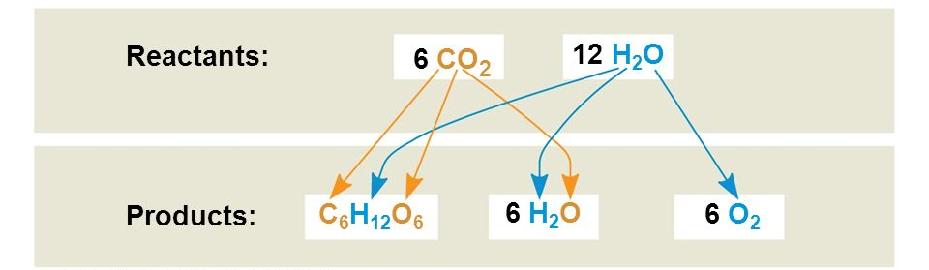

36) Know and be able to identify the parts of a chloroplast:

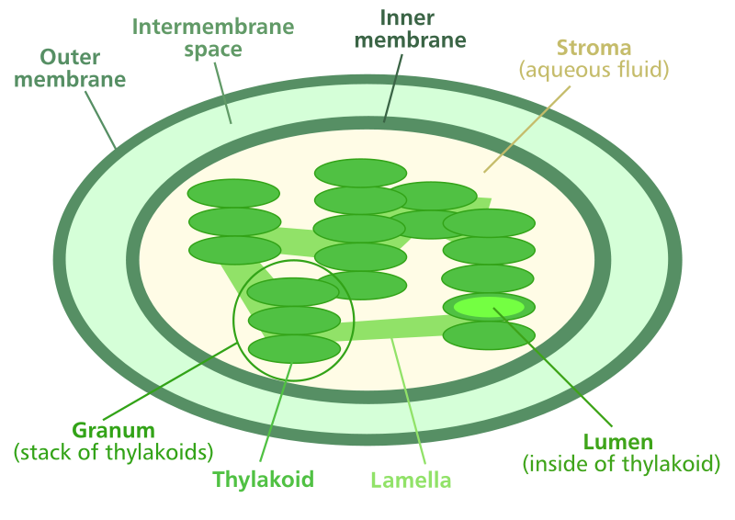

37) Which wavelengths of the visible light spectrum are most energetic? Which is least energetic?
The most energetic wavelengths of the visible light are the violet waves. The least energetic wavelengths are the red waves.

38) What is the basis for fluorescence that is exhibited by many chemical compounds (including the process that takes place in fluorescent light bulbs)? How does this relate to the behavior of chlorophyll in plants?
Fluorescence in chemical compounds occurs when they emit light after absorbing light or any other form of electromagnetic radiation.
Chlorophyll molecules re-emit light after they have absorbed the sun’s light hence displaying fluorescence.

39) What is an absorption spectrum? Why is chlorophyll green?
An absorption spectrum is a band of colors of electromagnetic radiation traveling through a substance that shows dark lines when specific wavelengths have been absorbed.
Chlorophyll is green because the green light is not absorbed by chlorophyll molecules but reflected making it appear green.

40) Be able to fill in the blanks of this diagram:

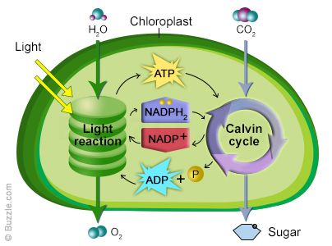
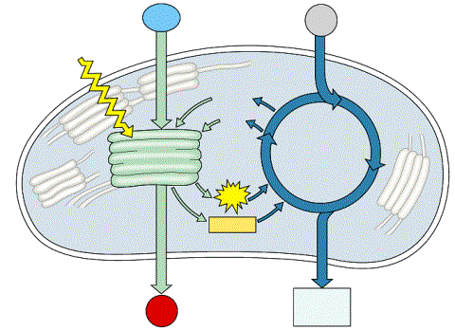

41) What do the light-dependent reactions of photosynthesis produce?
Light-dependent reaction reactions produce one molecule of oxygen gas and four hydrogen ions.

42) Why is photosystem I in photosynthesis considered cyclic?
This is because the electrons travel in a cyclic manner.

43) What is the source of electrons to the non-cyclic photophosphorylation pathway?
Photolysis

44) What are accessory pigments? Why do leaves turn colors in the fall?
Accessory pigments are light-absorbing compounds that work hand-in-hand with chlorophyll and are present in photosynthetic organisms.
In the fall chlorophyll disintegrates making the green pigment to disappear hence turning the leaves to yellow and eventually orange. Further chemical reactions may take place to produce extra colors on the leaves.

45) What is the overall, balanced equation for photosynthesis? Where do the oxygen atoms in the O₂ produced come from?
6CO₂+12H₂O C₆H₁₂0₆+6O₂
They come from photolysis, the splitting of water molecules into hydrogen and oxygen ions.

46) Describe the difference between the light dependent and light-independent reactions in photosynthesis.
Light-dependent reactions take place in the grana while light-independent reactions take place in the stroma.
Light-dependent reactions use light energy absorbed by chlorophyll and other photosynthetic pigments to form ATP while light-independent reactions utilize energy from light reactions to synthesize chemical products from simple inorganic materials.

47) Describe the Calvin cycle in photosynthesis.
The Calvin cycle is a set of light-dependent chemical reactions that use ATP and NADPH to convert carbon IV oxide to sugar. The cycle is divided into three main phases: carbon fixation, reduction, and regeneration of ribulose biphosphate. Each molecule of carbon IV oxide is attached to the RuBP in presence of Rubisco to form a compound that is unstable and that splits into two molecules of 3-phosphoglycerate. One of the molecules is converted to sugar while the other molecule is combined with ATP to form ribulose biphosphate after which the process begins again.

48) What is photorespiration? What advantage do C₄ plants have over C₃ plants with respect to photorespiration?
The presence of phosphoenolpyruvate carboxylase in C₄ plants that catalyzes the breakdown of carbon dioxide by Rubisco in high oxygen concentration. The absence of in C₃ plants renders rubisco inefficient in high levels of oxygen.
Photorespiration is a plant metabolism process whereby enzyme Rubisco oxygenates RuBP leading to loss of the energy produced during photosynthesis.

49) What does it mean to say that CO₂ has become fixed during photosynthesis?
It means that CO₂ from the atmosphere has been converted to an organic form such as carbohydrates.

50) How does a spectrophotometer work?
The light source is a lamp that produces a light ray which is directed to a diffraction grating. The light beam is split into its constituent wavelengths which then proceed to the exit slit. Since it is only a particular wavelength required to pass through the exit slit, the diffraction grating is rotated continually. The light then passes through the sample. A detector measures the total light amount passing past the sample as well as the amount of light the sample absorbs. Finally, the detector converts the information to a digital display.

Define: accessory pigments, stroma, thylakoids, stomata, extracellular matrix, rubisco, autotroph, heterotroph, carnivore,
Accessory pigments are light-absorbing compounds that work hand-in-hand with chlorophyll and are present in photosynthetic organisms.
Stroma is the fluid between grana in chloroplasts where the dark stage of photosynthesis takes place.
Thylakoids are flattened sacs arranged to form grana where the light stage takes place.
Stomata are the pores on the leaf epidermis that allow passage of gases and water in and out of the leaf.
Extracellular matrix is a combination of molecules secreted by cells to provide additional structural support to the surrounding cells.
Rubisco is an enzyme found in chloroplasts that facilitates carbon (IV) oxide fixation.
An autotroph is an organism that manufactures its own food from simple inorganic substances.
A heterotroph is an organism that takes in complex food materials like carbohydrates and breaks them down into simple soluble compounds.
Carnivore is an animal that feeds entirely on flesh.

